1. Create Network

Adapter Path: com.td.network.max.TDMaxAdapter

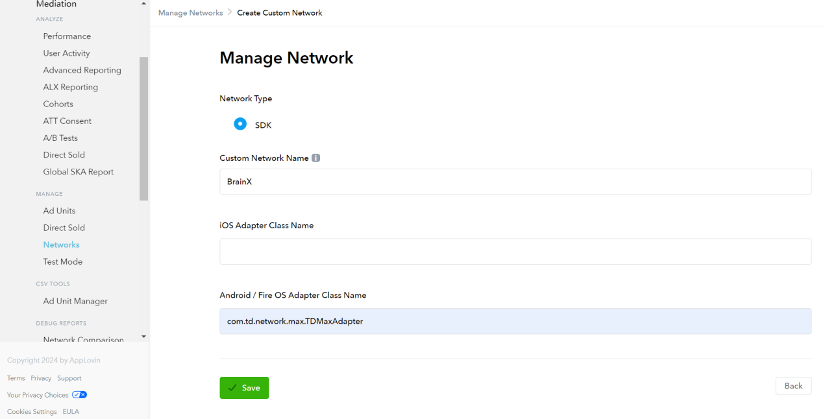

1. Enter your app id and placement id

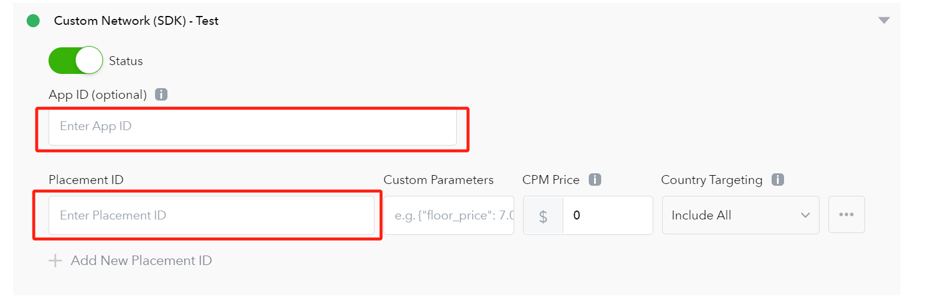

Notice：SDK Proguard rules：  
     -keep class com.td.\*\* { \*; }  
    -keepclassmembers class com.td.\*\* {  
        @com.td.\* public \*;  
    }